Working with SAS Syntax

3.1 Mastering Fundamental Concepts 3-3
3.2 Diagnosing and Correcting Syntax Errors 3-10
Diagnosing and Correcting Syntax Errors 3-12
Diagnosing and Correcting Syntax Errors 3-15
Exercises 3-20
3.3 Chapter Review 3-21
3.4 Solutions 3-22
Solutions to Exercises 3-22
Solutions to Student Activities (Polls/Quizzes) 3-24
Solutions to Chapter Review 3-25

Mastering Fundamental Concepts
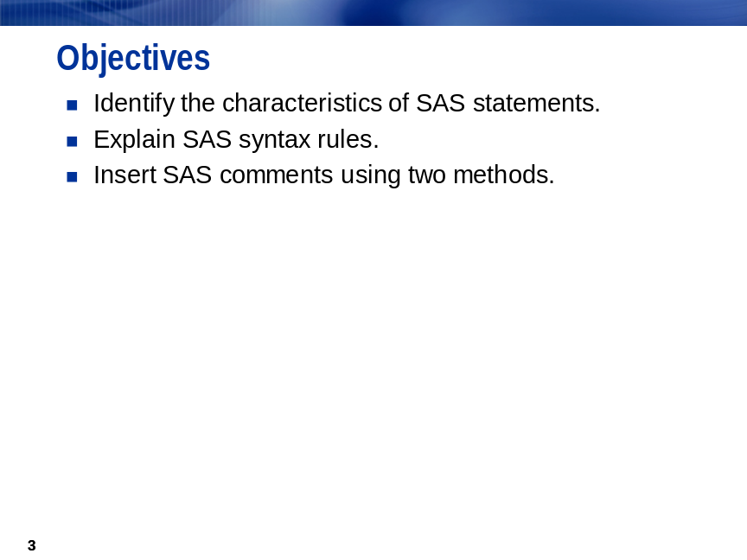
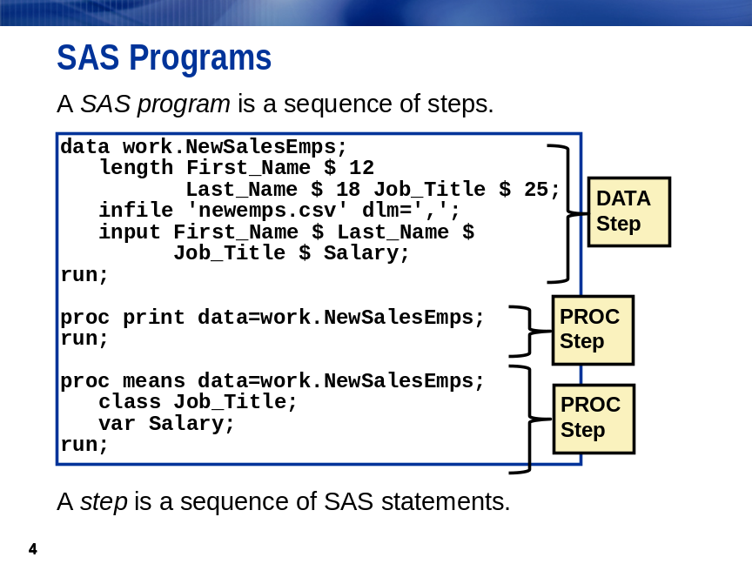
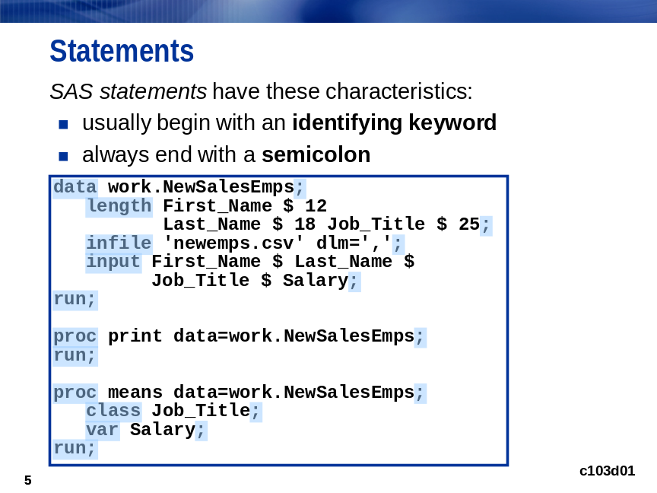
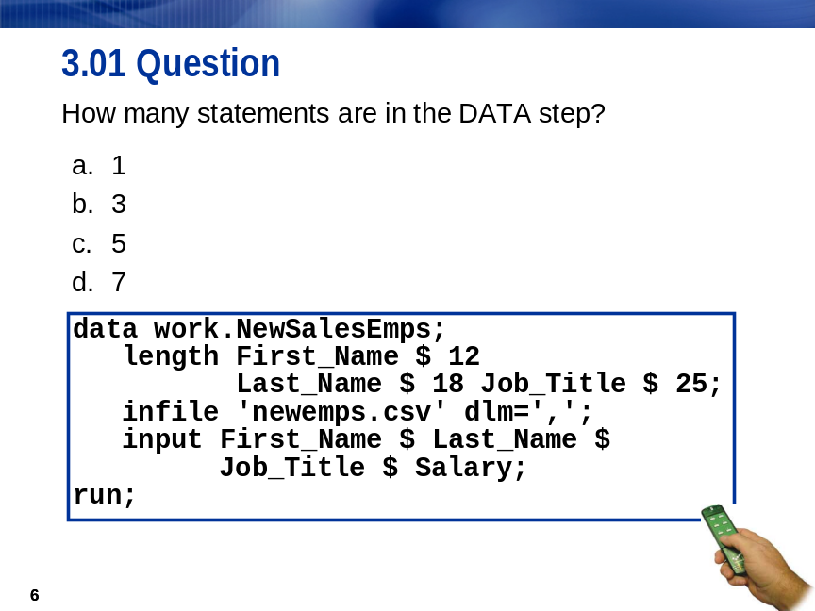
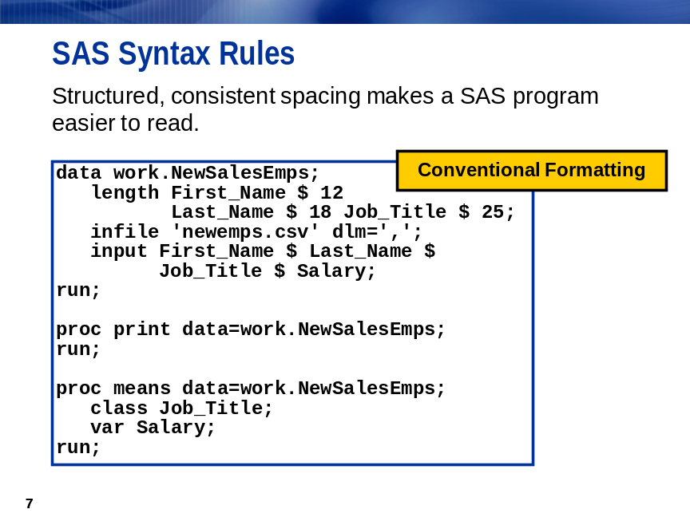
SAS programming statements are easier to read if you begin DATA, PROC, and RUN statements
in column one and indent the other statements.
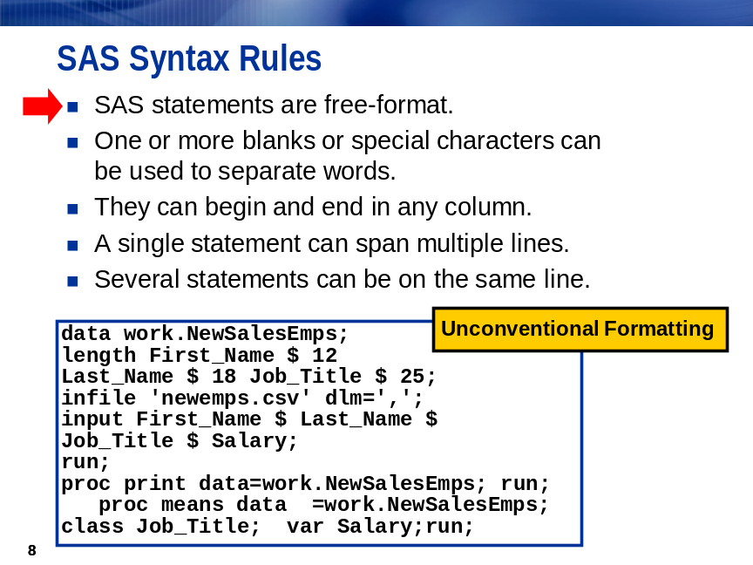
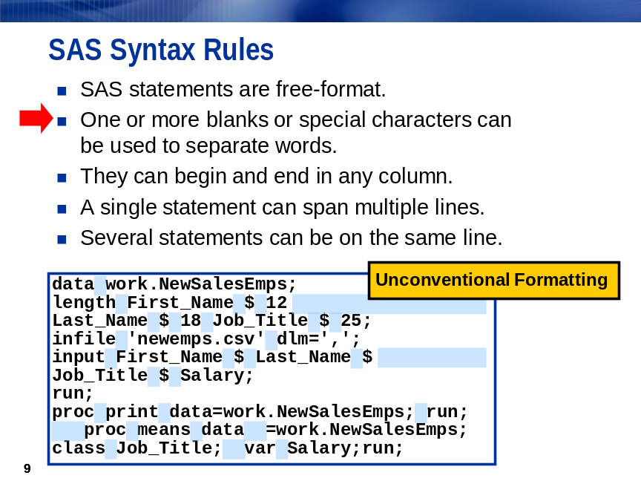
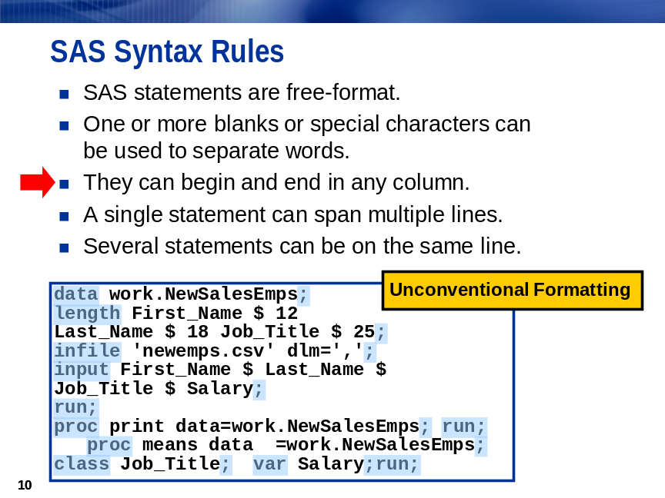
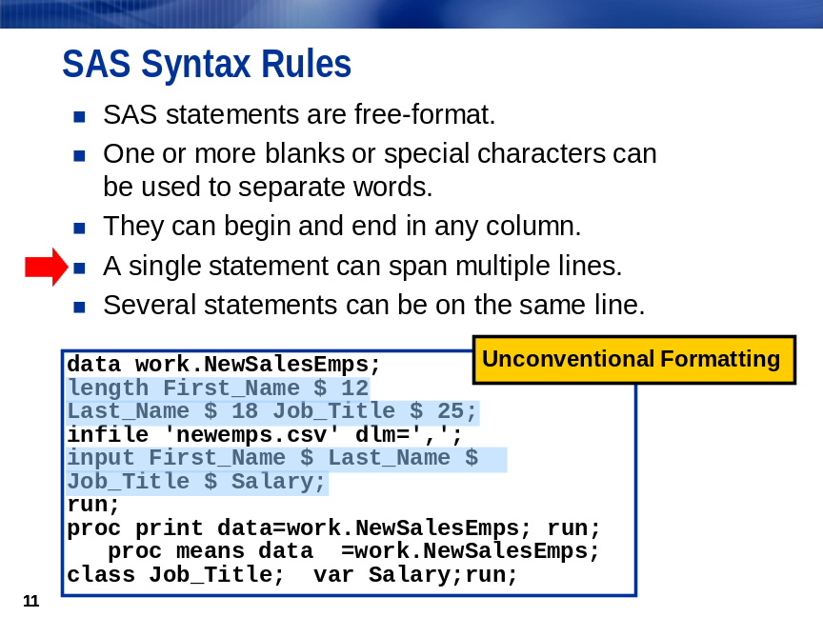
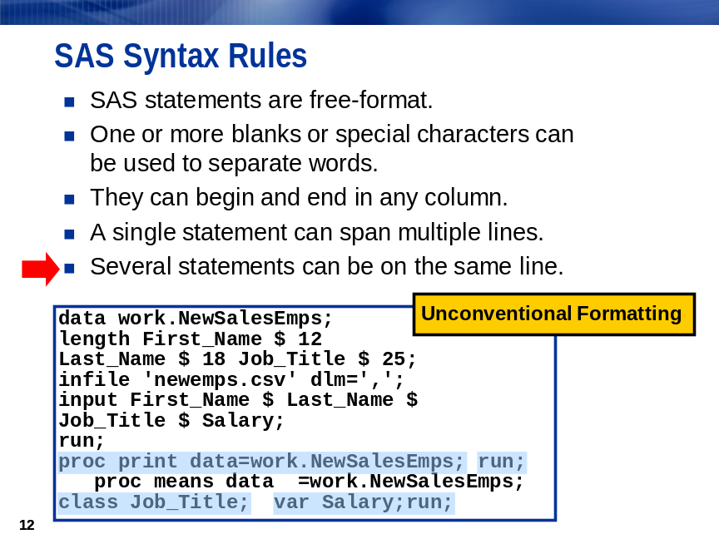
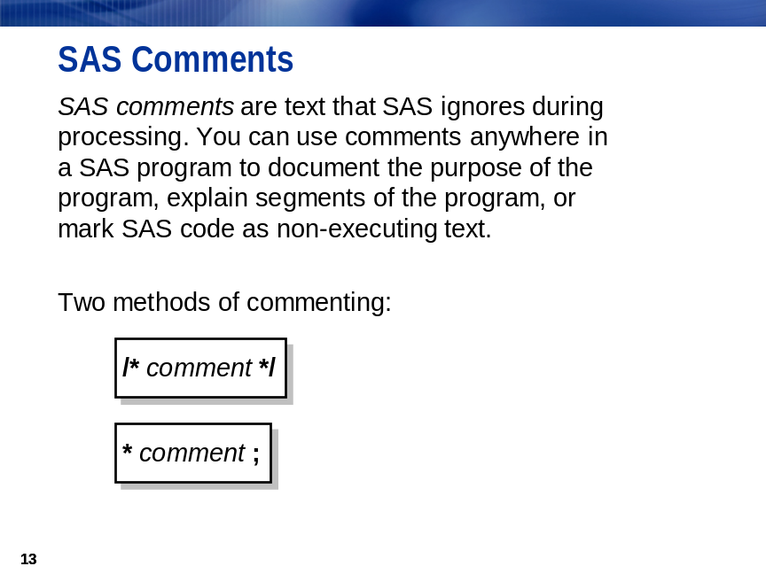
 Avoid placing the /* comment symbols in columns 1 and 2. On some operating environments, SAS might interpret these symbols as a request to end the SAS job or session.
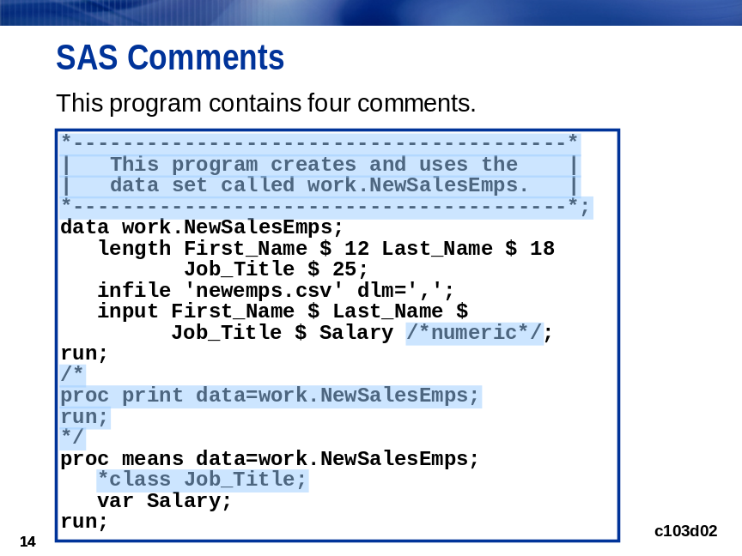
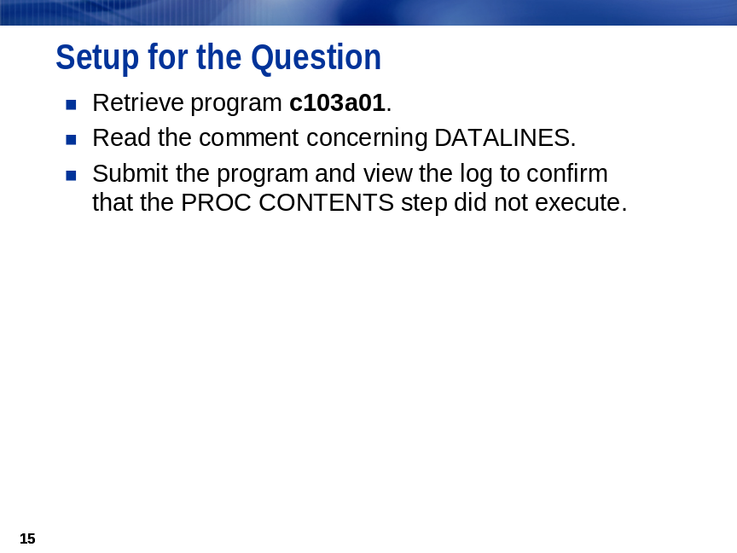

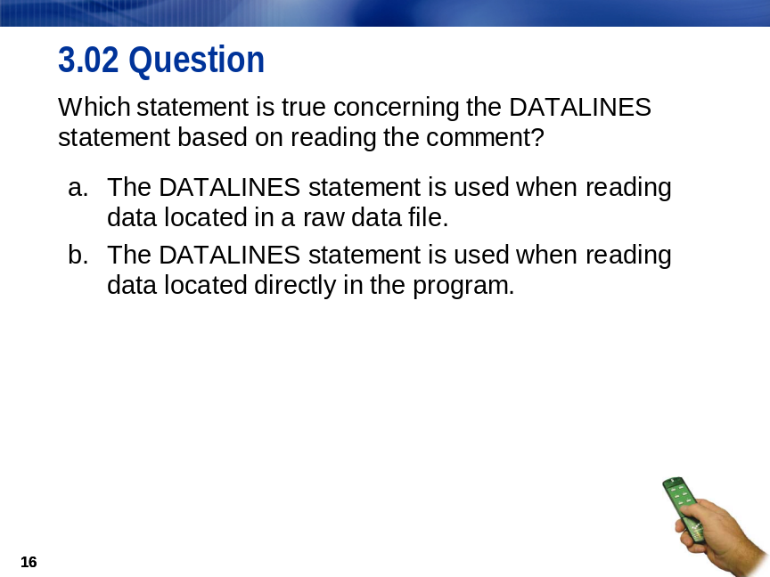

Diagnosing and Correcting Syntax Errors
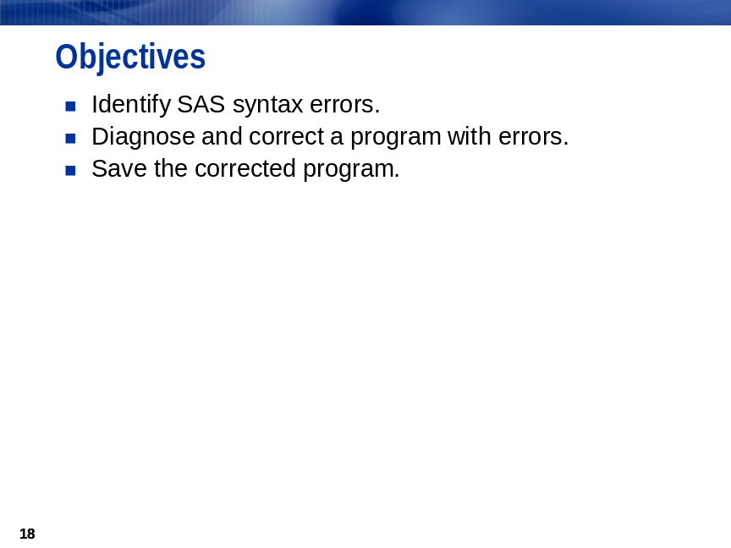
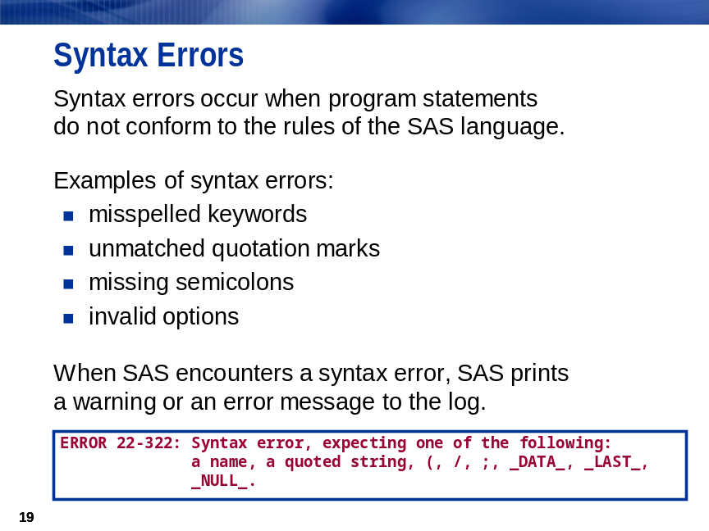
When SAS encounters a syntax error, SAS underlines the error and the following information is written
to the SAS log:
- the word ERROR or WARNING
- the location of the error
an explanation of the error

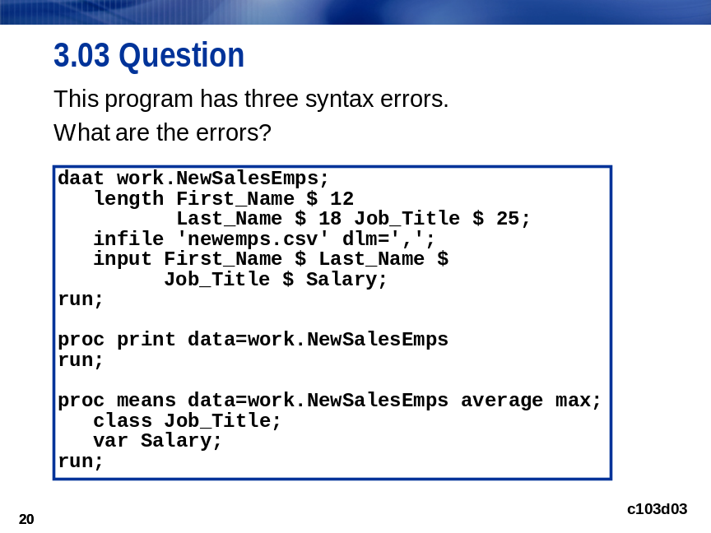
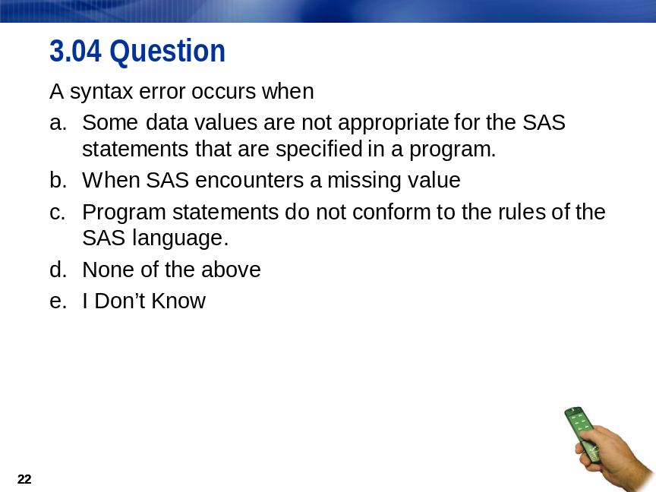


Diagnosing and Correcting Syntax Errors
c103d03

- Submit a SAS program with errors.
- Diagnose and correct the errors.
- Save the corrected program.

Submitting a SAS Program with Errors
daat work.NewSalesEmps;
length First_Name $ 12
Last_Name $ 18 Job_Title $ 25;
infile 'newemps.csv' dlm=',';
input First_Name $ Last_Name $
Job_Title $ Salary;
run;

proc print data=work.NewSalesEmps
run;

proc means data=work.NewSalesEmps average max;
class Job_Title;
var Salary;
run;
For z/OS (OS/390), the following INFILE statement is used:
infile '.workshop.rawdata(newemps)' dlm=',';
The SAS log contains error messages and warnings.
36 daat work.NewSalesEmps;
----
14
WARNING 14-169: Assuming the symbol DATA was misspelled as daat.

37 length First_Name $ 12
38 Last_Name $ 18 Job_Title $ 25;
39 infile 'newemps.csv' dlm=',';
40 input First_Name $ Last_Name $
41 Job_Title $ Salary;
42 run;

NOTE: The infile 'newemps.csv' is:
Filename=S:\Workshop\newemps.csv,
RECFM=V,LRECL=256,File Size (bytes)=2604,
Last Modified=02Apr2008:09:10:12,
Create Time=02Apr2008:09:10:12
(Continued on the next page.)

NOTE: 71 records were read from the infile 'newemps.csv'.
The minimum record length was 28.
The maximum record length was 47.
NOTE: The data set WORK.NEWSALESEMPS has 71 observations and 4 variables.

43
44 proc print data=work.NewSalesEmps
45 run;
---
22
202
ERROR 22-322: Syntax error, expecting one of the following: ;, (, BLANKLINE, DATA, DOUBLE,
HEADING, LABEL, N, NOOBS, OBS, ROUND, ROWS, SPLIT, STYLE, SUMLABEL, UNIFORM,
WIDTH.
ERROR 202-322: The option or parameter is not recognized and will be ignored.
46

NOTE: The SAS System stopped processing this step because of errors.

47 proc means data=work.NewSalesEmps average max;
-------
22
202
ERROR 22-322: Syntax error, expecting one of the following: ;, (, ALPHA, CHARTYPE, CLASSDATA,
CLM, COMPLETETYPES, CSS, CV, DATA, DESCEND, DESCENDING, DESCENDTYPES, EXCLNPWGT,
EXCLNPWGTS, EXCLUSIVE, FW, IDMIN, KURTOSIS, LCLM, MAX, MAXDEC, MEAN, MEDIAN, MIN,
MISSING, MODE, N, NDEC, NMISS, NOLABELS, NONOBS, NOPRINT, NOTHREADS, NOTRAP,
NWAY, ORDER, P1, P10, P25, P5, P50, P75, P90, P95, P99, PCTLDEF, PRINT, PRINTALL,
PRINTALLTYPES, PRINTIDS, PRINTIDVARS, PROBT, Q1, Q3, QMARKERS, QMETHOD, QNTLDEF,
QRANGE, RANGE, SKEWNESS, STDDEV, STDERR, SUM, SUMSIZE, SUMWGT, T, THREADS, UCLM,
USS, VAR, VARDEF.
ERROR 202-322: The option or parameter is not recognized and will be ignored.
48 class Job_Title;
49 var Salary;
50 run;

NOTE: The SAS System stopped processing this step because of errors.

Diagnosing and Correcting the Errors
The log indicates that SAS
- assumed that the keyword DATA was misspelled and executed the DATA step
- interpreted the word RUN as an option in the PROC PRINT statement (because there was a missing semicolon), so PROC PRINT was not executed
- did not recognize the word AVERAGE as a valid option in the PROC MEANS statement, so the PROC MEANS step was not executed.
- If you are using the Enhanced Editor, the program remains in the editor.
However, if you use the Program Editor, the code disappears with each submission. Use the RECALL command or select Run ⇨ Recall Last Submit to recall the program that you submitted. The original program is copied into the Program Editor.
- Edit the program.
  - Correct the spelling of DATA.
  - Put a semicolon at the end of the PROC PRINT statement.
  - Change the word AVERAGE to MEAN in the PROC MEANS statement.
data work.NewSalesEmps;
length First_Name $ 12
Last_Name $ 18 Job_Title $ 25;
infile 'newemps.csv' dlm=',';
input First_Name $ Last_Name $
Job_Title $ Salary;
run;

proc print data=work.NewSalesEmps;
run;

proc means data=work.NewSalesEmps mean max;
class Job_Title;
var Salary;
run;
- Submit the program. It runs successfully without errors and generates output.

Saving the Corrected Program
You can use the FILE command to save your program to a file. The program must be in the Enhanced Editor or Program Editor before you issue the FILE command. If the code is not in the Program Editor, recall your program before saving the program.
Windows or UNIX | file 'myprog.sas'
z/OS (OS/390) | file '.workshop.sascode(myprog)'
You can also select File ⇨ Save As.
A note appears that indicates that the statements are saved to the file.

Diagnosing and Correcting Syntax Errors
c103d04

- Submit a SAS program that contains unbalanced quotation marks.
- Diagnose and correct the error.
- Resubmit the program.

Submitting a SAS Program that Contains Unbalanced Quotation Marks
The closing quotation mark for the DLM= option in the INFILE statement is missing.
data work.NewSalesEmps;
length First_Name $ 12 Last_Name $ 18
Job_Title $ 25;
infile 'newemps.csv' dlm=',;
input First_Name $ Last_Name $
Job_Title $ Salary;
run;

proc print data=work.NewSalesEmps;
run;

proc means data=work.NewSalesEmps;
class Job_Title;
var Salary;
run;
SAS Log
51 data work.NewSalesEmps;
52 length First_Name $ 12 Last_Name $ 18
53 Job_Title $ 25;
54 infile 'newemps.csv' dlm=',;
55 input First_Name $ Last_Name $
56 Job_Title $ Salary;
57 run;
58
59 proc print data=work.NewSalesEmps;
60 run;
61
62 proc means data=work.NewSalesEmps;
63 class Job_Title;
64 var Salary;
65 run;

Diagnosing and Correcting the Errors
There are no notes in the SAS log because all of the SAS statements after the DLM= option became part of the quoted delimiter.
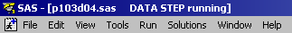
 The banner in the window indicates that the DATA step is still running, and it is still running because the RUN statement was not recognized.
You can correct the unbalanced quotation marks programmatically by adding the following code before your previous statements:
*';*";run;
If the quotation mark counter within SAS has an uneven number of quotation marks, as seen in the above program, SAS reads the quotation mark in the code above as the matching quotation mark in the quotation mark counter. SAS then has an even number of quotation marks in the quotation mark counter and runs successfully, assuming no other errors occur. Both single quotation marks and double quotation marks are used in case you submitted double quotation marks instead of single quotation marks.

Point-and-Click Approaches to Balancing Quotation Marks
Windows
- To correct the problem in the Windows environment, click the break icon or press
the CTRL and Break keys.
- Select 1. Cancel Submitted Statements in the Tasking Manager window and select OK.
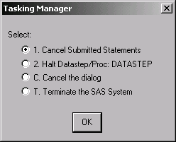
- Select Y to cancel submitted statements, ⇨ OK.
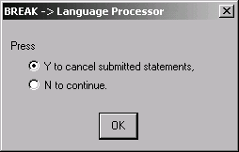
UNIX
- To correct the problem in the UNIX operating environment, open the SAS: Session Management window and select Interrupt.
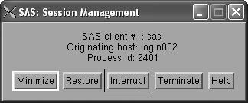
- Select 1 in the SAS: Tasking Manager window.
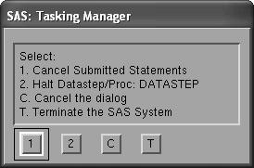
- Select Y.
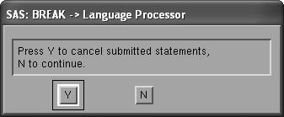

z/OS (OS/390)
- To correct the problem in the z/OS (OS/390) operating environment, press the Attention key
or issue the ATTENTION command.
- Type 1 to select 1. Cancel Submitted Statements and press the ENTER key.
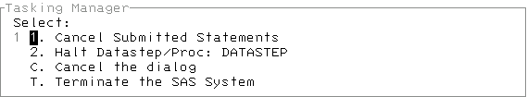
- Type Y and press ENTER.

Resubmitting the Program
- In the appropriate Editor window, add a closing quotation mark to the DLM= option in the INFILE statement.
data work.NewSalesEmps;
length First_Name $ 12 Last_Name $ 18
Job_Title $ 25;
infile 'newemps.csv' dlm=',';
input First_Name $ Last_Name $
Job_Title $ Salary;
run;

proc print data=work.NewSalesEmps;
run;

proc means data=work.NewSalesEmps;
class Job_Title;
var Salary;
run;
- Resubmit the program.
 When you make changes to the program in the Enhanced Editor and did not save the new version of the program, the window bar and the top border of the window reflect that you changed the program without saving it by putting an asterisk (*) beside the window name.
When you save the program, the * disappears.

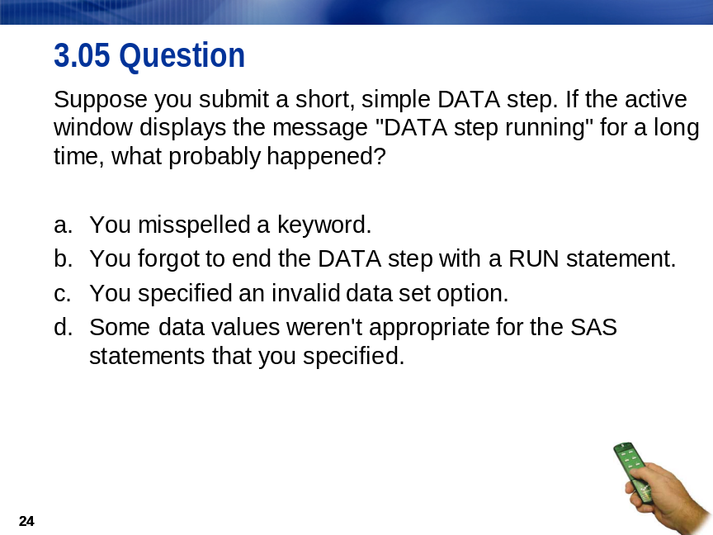


Exercises

Level 1
- Diagnosing and Correcting a Misspelled Word
  - With the appropriate Editor window active, include the SAS program c103e01.
  - Submit the program.
  - Use the notes in the SAS log to identify the error.
  - Correct the error and resubmit the program.

Level 2
- Diagnosing and Correcting a Missing Statement
  - With the appropriate Editor window active, include the SAS program c103e02.
  - Submit the program.
  - Are there any errors in the SAS log? _____________________________________________
  - Notice the message in the title bar of the Editor window.
  - Why is PROC PRINT running? _________________________________________________
  - Add the missing statement to execute the PROC PRINT step.
  - Submit the added statement.
  - Confirm that the output was created for the program by viewing the Log and Output windows.

Level 3
- Using the Help Facility to Determine the Types of Errors in SAS
  - In the Help facility, type syntax errors on the Index tab.
  - Double-click syntax errors in the results box.
  - In the Topics Found pop-up box, select Error Processing and Debugging: Types of Errors in SAS.
  - Name the five types of errors.
____________________________________________________________________________

Chapter Review
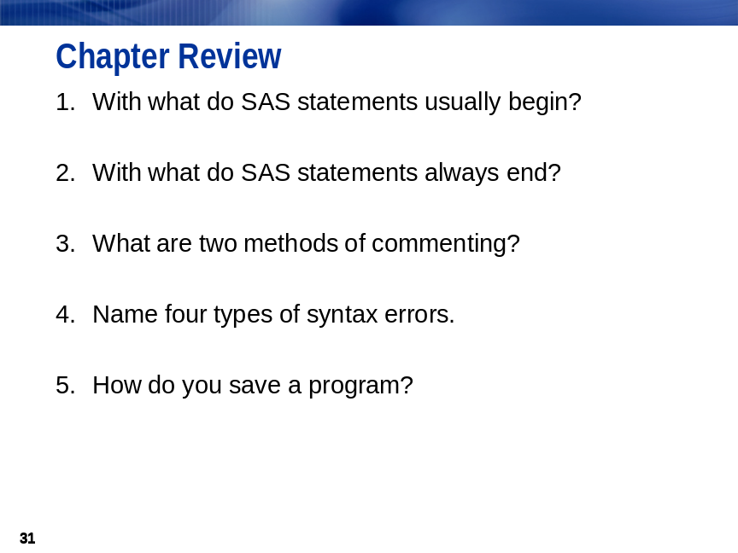

Solutions

Solutions to Exercises
- Diagnosing and Correcting a Misspelled Word
  - Include the SAS program.
  - Submit the program.
  - Use the notes in the SAS log to identify the error.
  - Correct the error.
data work.country;
length Country_Code $ 2 Country_Name $ 48;
infile 'country.dat' dlm='!';
input Country_Code $ Country_Name $;
run;

proc print data=work.country;
run;
- Diagnosing and Correcting a Missing Statement
  - Include the SAS program.
  - Submit the program.
  - Are there any errors in the SAS log? No
  - Notice the message in the title bar.
  - Why is PROC PRINT running? The PROC PRINT step is missing a RUN statement.
  - Add the missing statement.
data work.donations;
infile 'donation.dat';
input Employee_ID Qtr1 Qtr2 Qtr3 Qtr4;
Total=sum(Qtr1,Qtr2,Qtr3,Qtr4);
run;

proc print data=work.donations;
run;
  - Submit the added statement.
  - Confirm that the output was created.
- Using the Help Facility to Determine the Types of Errors in SAS
  - In the Help facility, type syntax errors on the Index tab.
  - Double-click syntax errors in the results box.
  - Select Error Processing and Debugging: Type of Errors in SAS.
  - Name the five types of errors.
Syntax: when programming statements do not conform to the rules of the SAS language compile time
Semantic: when the language element is correct, but the element might not be valid for a particular usage compile time
Execution-time: when SAS attempts to execute a program and execution fails execution time
Data: when data values are invalid execution time
Macro-related: when you use the macro facility incorrectly

Solutions to Student Activities (Polls/Quizzes)

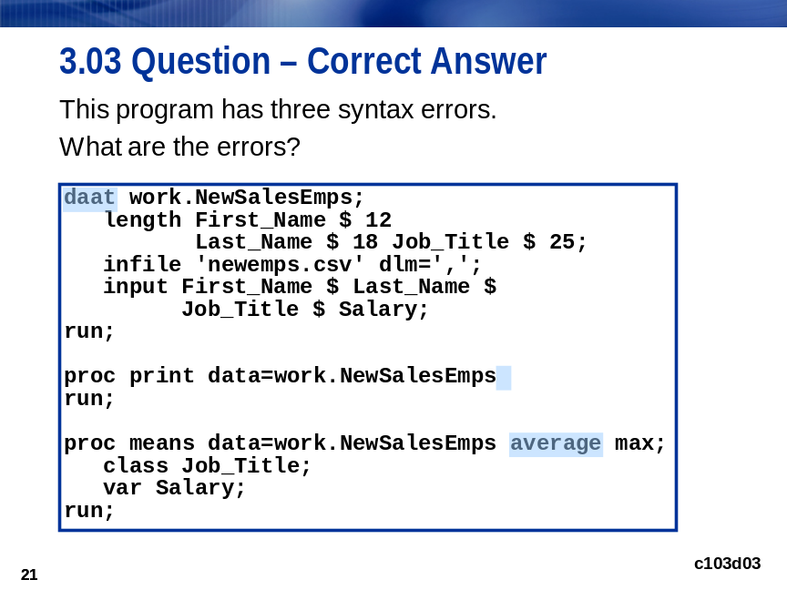

Solutions to Chapter Review
